Name of the Good Practice:  RESPIGA is a small carpentry workshop, located in the center of Parede, Cascais, which develops products based on the reuse of materials, mainly solid wood.  They avoid the use of "new" wood, as well as its derivatives (agglomerates, mdf, etc.) because of their poor durability, strength and impact. | Contact:  Name: Rui Bispo and Claudia Martins  (+351) 916827781 (Rui) 914608834 (Cláudia)  Address: Rua José Elias Garcia, 29  2775-217 Parede, Cascais Portugal  Webpages :  https://www.facebook.com/respigaportugal/  https://respiga.wixsite.com/respiga-oficina  https://www.pinterest.pt/respigaecodesign/  Mail: respiga.ecodesign@gmail.com
Domain concerned:  Good Practice - General  Good Practice - Collection  Good Practice - Valorization | Good Practice - Sale  Good Practice - Sensitization

Implementation context (territory, starting point, ...)

Funded on November 27th 2015
Center of Parede, Cascais – about 20 km from Lisbon

Practice, method of intervention and objectives of the approach

Respiga produces and sells pieces of furniture, art and design mainly designed from the reuse of materials, from wood resulting from works of demolition or rehabilitation of buildings, to materials found in the rubbish bins of the cities, countryside or beaches.

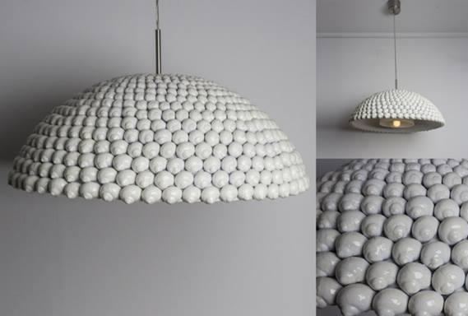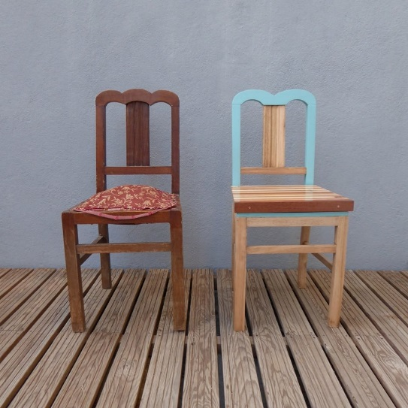

This is for what Respiga stands for:

WE RESPECT.
We compile, collect and transport wasted materials.

WE REUSE.
We make furniture, lamps and other pieces of art and design, from the reuse of materials.

WE REDEED.
We create pieces of timeless design, contrary to the concept of "disposable".

WE REFORM.
We manufacture the pieces, in full view, in our workshop.

RECOMMEND.
At the end of each cycle, we return to the beginning again, with new materials, new concepts and new pieces to produce.

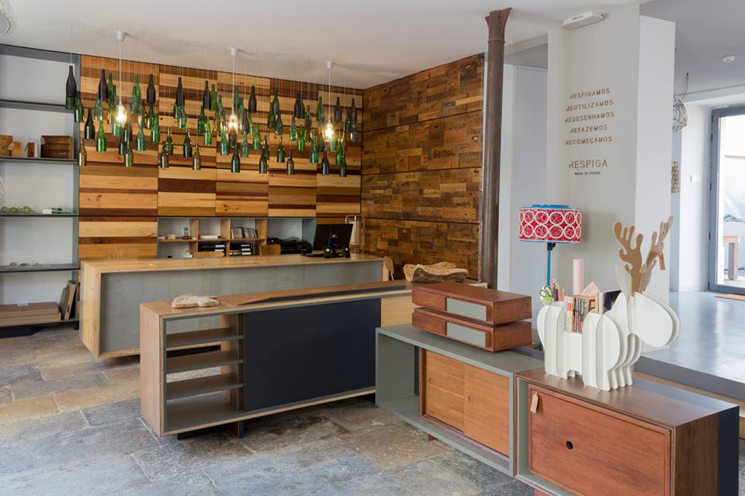

Results (impacts on the public, the territory, ...)  The Respiga workshop opens the doors with the aim of creating a space for sharing woodwork, and at the same time an incubator of other projects like “Respiga”.  The space allows the realization of individual projects in an environment of sharing of experiences and knowledge. They have available tools and machines of professional range necessary for the realization of projects, big and small, simple or bolder.  The added value is the possibility to project what we want to achieve, and "put the hands in the wood", experiment, learn, do.  The workshop has an area of ​​46 m², equipped with 4 individual work benches, which allows 4 people to work at the same time and in a rotating way, depending on the schedules each one occupies.  Each person has available a storage shelf for their material and tools, where they can also store the pieces in which they are working.  There is also an outdoor area with a washer tank where various activities can be carried out.  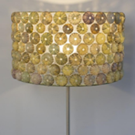  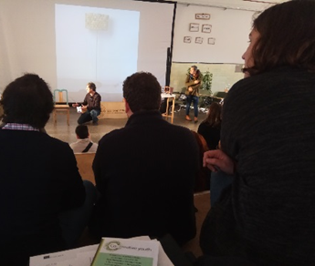 | Target audience:  Clients: General Public with interest for sustainable design;  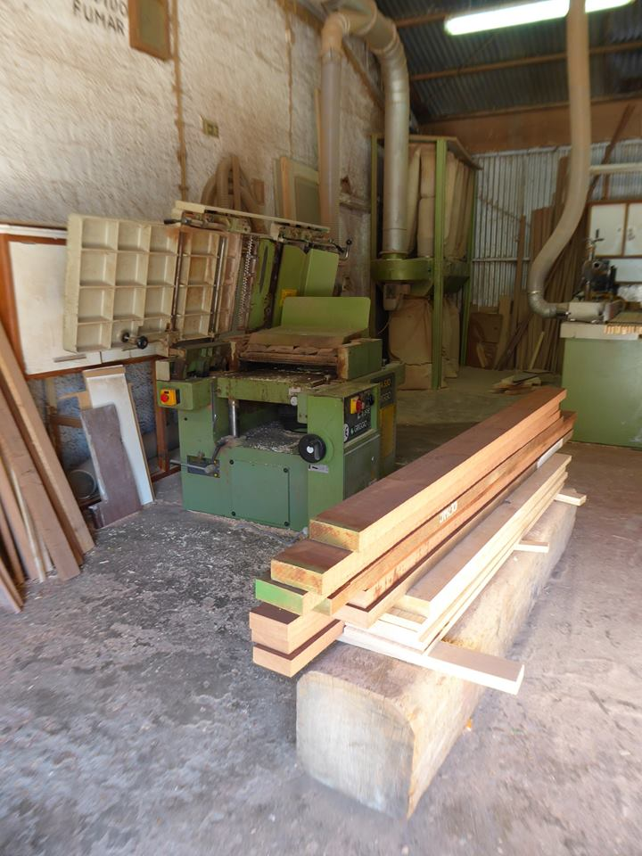  General public that wants to repair and recover old furniture.  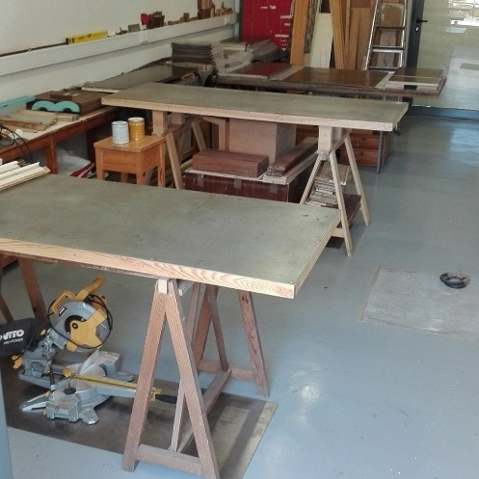
Perspective of use and dissemination:

Import their business model, with a social inclusion dimension, for example.
- Giving internships to young trainees;
- Employing lower skilled people;
- Employing disable people.

