Name of the Local event:  Poggiolo river Discovery day |  | Contact:  Edita Raffaelli  contact@ec-corsica.eu  tel : 04 95 38 03 87
Period:  1st of June 2017 | Target group:  inhabitants of the territory and public authorities | Objective:  Raise awareness among residents and public authorities of the environment, waste reduction and recovery/reuse activities.  Remind residents of good practices to better preserve the environment.  Make the general public aware of the recovery work carried out on the Poggiolo River.
Programme

- Discovery visit of a workshop and integration site around the cleaning and restoration work on the Miomo river, set up in connection with collective projects for the protection, development and management of natural areas. This discovery visit aims to raise awareness about the protection and conservation of this fragile natural heritage.
- demonstration workshop on waste recovery and reuse, introducing creative intelligence and promoting waste reuse and job creation.
- exhibition of objects created from recycled waste.

Partners involved in the organisation:
- Miomo City Hall
- Office de l’environnement de la Corse
- Etudes et chantiers Corsica

Implementation context

For more than two years the municipality of Santa Maria di Lota has been working with the Association Etudes et Chantiers Corsica to clean up the Poggiolo river, an operation that has served as a support for an integration and social mobilisation action particularly adapted to people facing real difficulties in job insertion.

The animation event of June 1, 2018 is initiated by Etudes et Chantiers Corsica and co-organized in partnership with the Office de l'environnement de la Corse and the Miomo City Hall.

It is part of the European Sustainable Development Week and the European Co-creative Youth project led by the Corsican Environment Office and its main objective was to make the general public aware of the recovery work carried out on the Poggiolo river.

Brief description:

This day around the Poggiolu River took the form of activities on sustainable development, exhibitions and workshops attended by Miomu schoolchildren, focusing on discovering nature, demonstrating wood harvesting, etc...
All those who had ventured their steps into the Poggiolu, dry at this time of year, could have discovered the work of cleaning and restoring the Santa Maria di Lota river, which had been set up in connection with collective projects for the protection, development and management of natural areas.

Impacts/opportunities for local partners – participants - territory :

Exchanges of experiences between professionals and young people present on the site have made it possible to better understand the challenges and practices in favour of sustainable development used as a factor of socio-economic inclusion.

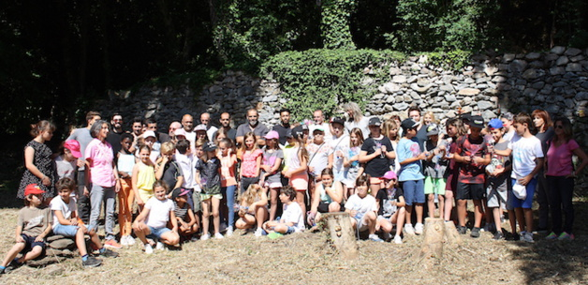
Dissemination/visibility:

*press article (Corse matin, 2nd of june 2017)
* TV report on France 3 Via Stella and a web article with a video report on the Corse net channel Info: http://www.corsenetinfos.corsica/Santa-Maria-di-Lota-Le-Poggiolu-rehabilite_a27637.html
* registration of the action on the website of the Ministry of Ecological and Solidarity Transition http://www.evenements.developpement-durable.gouv.fr/campagnes/evenement/8341

