Name of the Local event:  Hazardous Waste at the Day of Children’s Convention event. |  | Contact:  Eva Johansson  Gästrike återvinnare  eva.h.johansson@gastrikeatervinnare.se
Period:  20 Nov - 2018 | Target group:  2000 School children in year 5 and 6 in 24 different schools in Gävle. | Objective:  The aim of this big event was to see inform and educate the children about hazardous waste. What it is and how to recycle it. The importance of preventing the hazardous waste was also an important factor.
Programme:

08.30 The arena opens
08.30 – 10.40 Students arriving to Gavlerinken and starts taking part of the events that all the exhibitors have.
10.40- 10.55All students should be sitting down in their places in the arena.
11.00 -12.20 The show starts with singing and dancing numbers and ends with a secret guest. Result of the different assignments that students performed.
12.45 – 14.40 Activities concerning the child convention continues and students are leaving the arena by buses.

Partners involved in the organisation:

Brynäs If – the organisers and coordinators
Gästrike återvinnare – exhibitor
Gävle Energi – exhibitor
UF, Ung Företagsamhet – exhibitor
Gästrike Räddningstjänst – exhibitor
Mattecentrum – exhibitor
UNICEF – exhibitor
Gävle Gymnastikförening – exhibitor
HLR – exhibitor
LF - exhibitor

Implementation context  Since The European Week of Waste Reduction focuses on hazardous waste and we wanted to be a part of a big event. Gästrike återvinnare was asked to be one of the exhibitors in the big event attracting 2000 students in Gävle. Our main focus was to inform and educate students of what hazardous waste is and how to prevent it in daily life. We made a knowledge test were they could find most of the answers in the tent. |  |  | 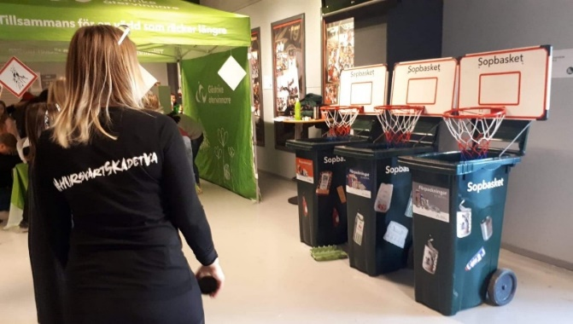
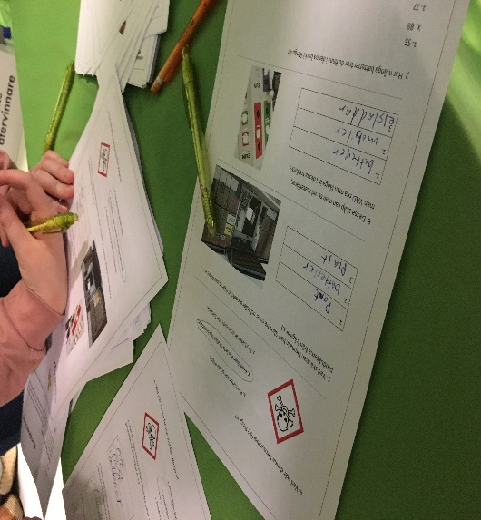 |  |  | Brief description:  The wastebasket was a chance to get the students to sort different material in the right basketbin to make it more interesting but also an active event.  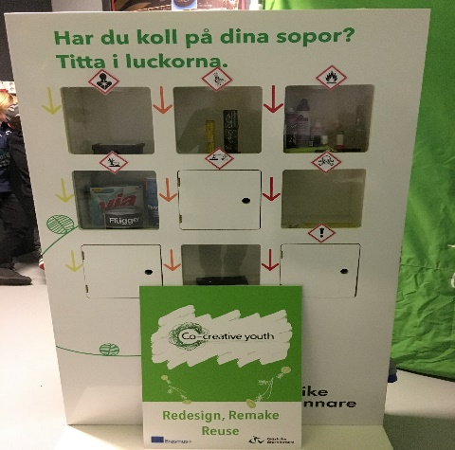  This cabinet was at display for the students showing hazardous waste and the signs that usually are seen on the packages. Some of the windows were closed and some of them could be open and looked inside.
Impacts/opportunities for local partners – participants - territory :

Hazardous waste is one of Gästrike återvinnares high priority areas and it is written in our waste plan to be highlighted in the coming years. To be able to meet so many students and teachers and have time to talk to them and make them reflect about hazardous waste is an important mission for us. The teachers are working in year 5 and 6 with this as a theme so the impact was direct. An added outcome can be that the students take this question home and discuss with their family and relatives.

Dissemination/visibility:

Municipal webpage and Facebook page, all exhibitors homepage, Instagram and Facebook pages.
Local TV, newspaper articles.

