Name of the Local event:  Awareness-raising actions and presence at the events Semaine de la Récup and Salon Récup'Date 2017 |  | Contact:  Donatienne Hargot  dhargot.aid.tubize@gmail.com  tel : +32 2 355 62 61
Period:  Saturday 25 March 2017  from 29 April 2017 to 07 May 2017 | Target group:  Brabant Wallon and le grand Charleroi residents | Objective:  AID BW-Eft Tubize Asbl is a work-based training company.  As such, it does not (yet) have a store in which to display the achievements of upcycling trainees.  To make up for this lack, it is part of events organised, in particular, by the Resources Federation, which is inspired by what is being done at European level.  Our objective is to raise awareness among the region's residents of the principles of recovery, reuse, recycling and transformation.
Programme

  - Semaine de la Récup
We have registered for the Recovery Day, which took place from April 29 to May 07, 2017.
This event receives wide media support: dissemination of the Federation's agenda, articles in newspapers, with their digital version, broadcast on RTBf, national television, although French-speaking, broadcast by environmental awareness sites.
This year, we have established a partnership with Folfouille (recycling center), which is also in Walloon Brabant (our province). We were able to display some of the items that our trainees had made, not only to sell them but also to raise awareness among the region's residents of the principles of recovery, reuse, recycling and transformation..
  - Salon Récup'Date
And we were present at the Récup'Date exhibition in Charleroi.
We rented a stand in order, once again, to present our work, but also to lead information and awareness sessions on the principle of the 3Rs but also on the opportunities in the employment of sorter.In fact, this event takes place before the European Sustainable Development Week (30 May to 05 June 2017)
As we are members of the Resource Federation, it seems logical to us to participate in events organized on the same theme, although in advance.
  - Other participation on the same topic:
We also participate in other events, further into the year. For example, we were present at the "seed exchange" organized by la Maison du Développement Durable de Louvain-la-Neuve (25 March 2017).
Finally, la Maison des Jeunes de Tubize (MJ AntistaticTubize -http://www.mjantistatic.be) has ordered us bins to grow vegetables in the "incredible edible" project".
This Youth Centre has obtained the MJ Verte label. Because "for many years, the Collective has been part of a sustainable approach, both for the young people who attend the MJs and their teams, and for the general public. This is achieved through individual actions: sorting waste, vegetable gardens, compost, responsible purchasing, but also through actions common to all 10 MJ[Walloon Brabant]: reusable cups, corn concert tokens, encouraging cycling and the train…
All this ended up being a green spot and the "MJ Verte" project was born!
Through these new practices and the values they convey, the Maison des Jeunes objective is for young people to take responsibility and assert their citizenship as actors of change in the face of an overconsumption society that depletes natural resources, pollutes and leads to major inequalities".
We are pleased to have already delivered 5 bins, which are gradually being installed in the entity's municipalities. Three others are in preparation.
And as good ideas are in demand, the CPAS (Centre Public d'Actions Sociales) has just ordered us a set of bins to equip social houses on the same principle of "Incroyables Comestibles".
Finally, we are in talks with the Municipal Social Service to equip social housing with compost bins and bins to grow vegetables.

Partners involved in the organisation:
- Fédération Ressources Asbl
- Folfouille, ressourcerie de Braine l'Alleud
- Maison des Jeunes de Tubize : MJ AntistaticTubize
- CPAS de Tubize
- Maison du Développement Durable de la Ville d'Ottignies – Louvain –La -Neuve

Implementation context  The training courses offered by AID are mainly intended for people seeking employment, with little or no qualifications, for reintegration after a stay in prison, and for young people who have dropped out of society.  The achievements of our trainees are shown during these events and they carry messages to raise awareness against waste, recovery and transformation of waste resources into new marketable objects.  We therefore participate, as much as possible, in events organized by the Resources Federation and in events that meet our objectives. |  |  | 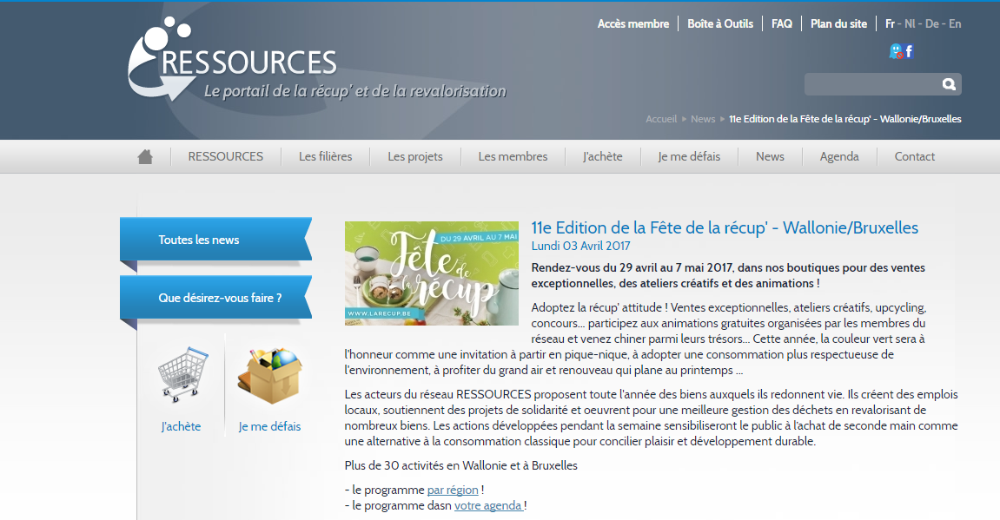
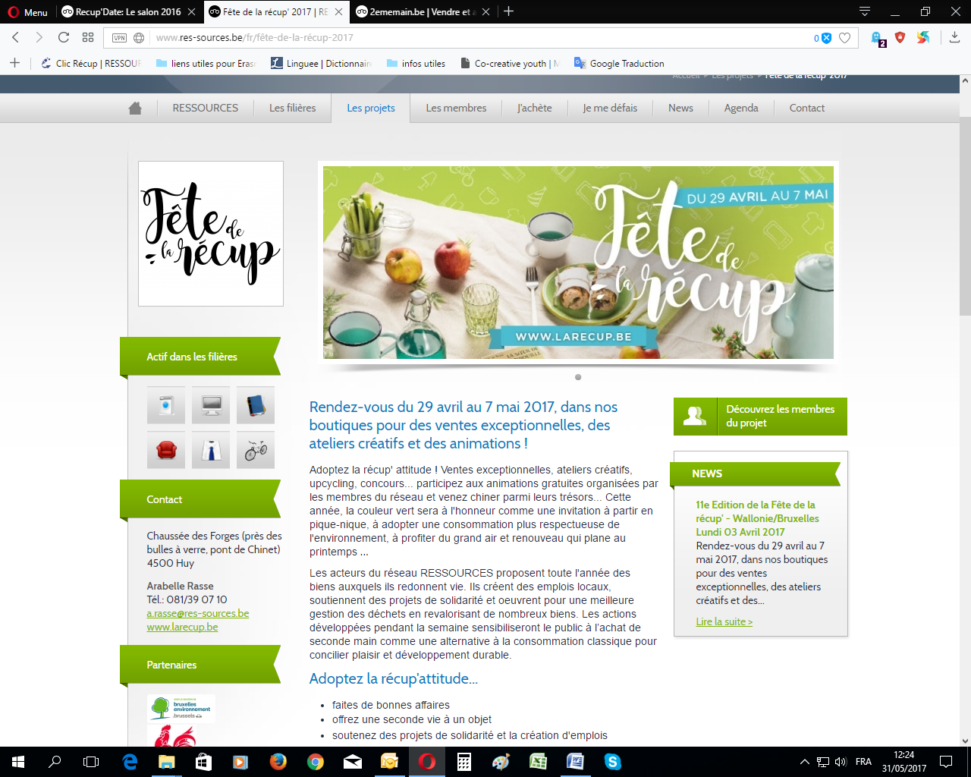 |  |  | Brief description:  Participation at the Récup'Date exhibition was an opportunity for trainees and trainers to meet the public, to present manufactured products made from objects of recovery or reuse, and to promote the attitude of the 4Rs: reduce waste, recover, reuse, revalue the waste resource.  The partnership with La Folfouille has strengthened our collaborations and made it possible to open up the work of our trainees and the impact of our training to a wider audience
Impacts/opportunities for local partners – participants - territory :

The exchanges, during the Fairs or during the participation in the Seed Exchange (Ottignies), allow the public to discover not only the training work but also the work resulting from these trainings.

These are always rich exchanges for trainees who, for the most part, are proud to present and comment on their work to complete strangers. The recognition of their know-how is important for them, and rewarding.

The collaborations for these events mutually reinforce our positions and visibility; in addition, following the actions proposed by the Resources Federation allows us to be in line with European activities.

Dissemination/visibility:

dissemination in the media (newspapers, regional radio, RTBf) and on the Internet

http://www.mjantistatic.be/label-mj-verte/, pages consultées le 31/05/2017
http://lesincroyablescomestibles.fr/europe/belgique/, pages consultées le 31/05/2017

