Name of the Local event:  Now « Festival des Initiatives de Transition » |  | Contact:  Donatienne Hargot  dhargot.aid.tubize@gmail.com  tel : +32 2 355 62 61
Period:  May – June 2018 | Target group:  Louvain-la-Neuve residents | We have been invited by the City of Louvain-La-Neuve to participate in the "Festival des Initiatives de Transition". 5 days / 5 themes: Renewable energies, Emerging economic and participatory models, Internal transition, Open pedagogies, Local agriculture
Programme
- For the event, we created a stand that includes a panel for the reuse of recycled wood (pallets or construction wood), as well as other materials (e. g. cardboard).
- Our goal was essentially informative: reuse, saving resources, sustainable consumption, a more solidarity-based and fair economy
- We were surrounded by other associations working in the same concepts (Oxfam, Cyreo, Restor, etc.).
- For a few hours, we also hosted a meeting of the Fédération Ressources, which brings together social economy enterprises.
- We had the opportunity to explain, over and over again, the benefits of sorting, recycling, reuse, reuse, measures against waste, etc.

Partners involved in the organisation:

- City of Louvain-la-Neuve

Implementation context  - A very multi-cultural, intergenerational transition of users, most of whom are already aware of the actions carried out by the project “Maintenant”  - Very informative contacts, which show that among the youngest people the notion of recovery is well established (clothing, furniture, household appliances, etc.). Sometimes for strictly financial reasons, often by conscious choice of the impact of this way of life |  |  | 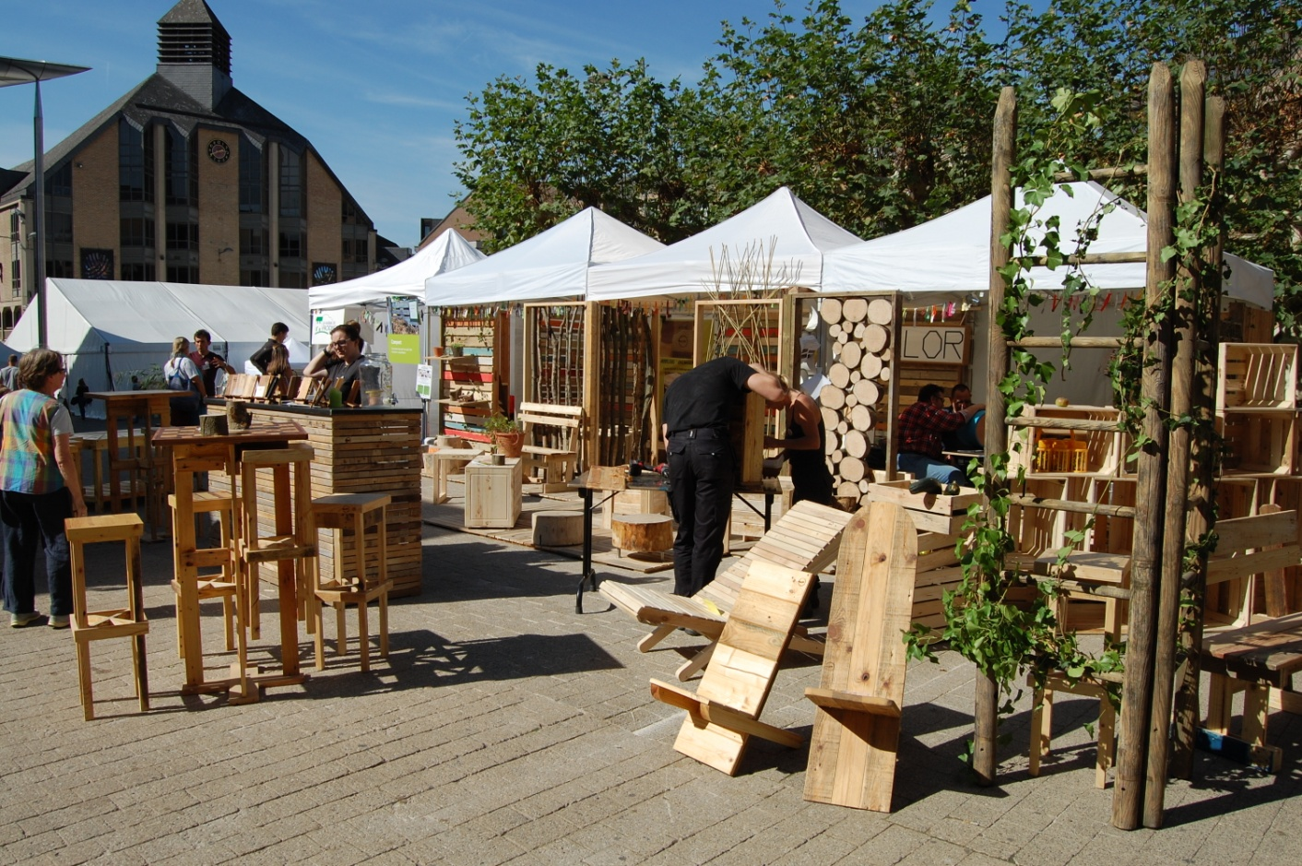
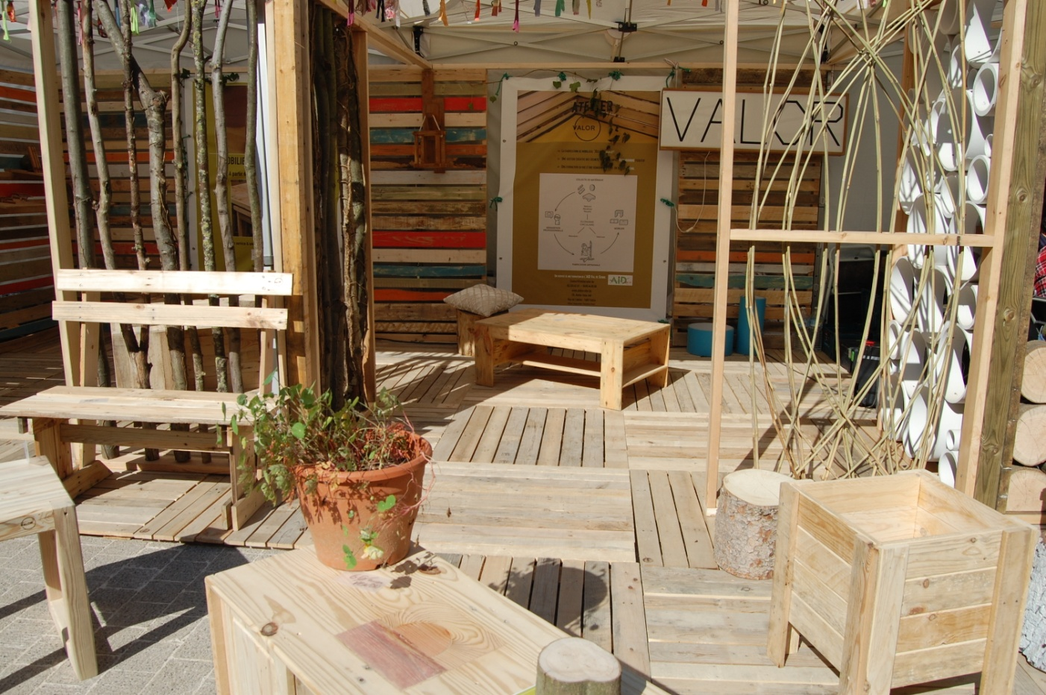 |  |  | Brief description:  The City of Louvain-la-Neuve is essentially a student city (University) but it is also a city, with an increasingly intergenerational mix, as well as an important cultural mix (very many nationalities cross paths in the city).  We wanted to reach in particular the youngest, students or families, who live there, or who were passing through
Impacts/opportunities for local partners – participants - territory :
- We also hope to reach other businesses in order to initiate a zero-waste spirit and welcome recovery in these times of intense waste.
- Traders are beginning to take an interest in it because our products, while respecting the environment in the broadest sense, are also more economical and... recyclable.

Dissemination/visibility:

- We had many contacts of people interested in our products, seduced by the principle of recovery and the quality of our achievements (which prove that reuse can have the same appearance as new in terms of visual quality, the charm in addition)
- The stand we manufactured will be reused for the Récup'Ere exhibition to be held in November in Namur.
- Our cross-participation with other associations active in similar fields leads to a gregarious movement, the one that animates people who want to change.
- To use the Festival's slogan: "tomorrow is now"!
- Paper and video reports were produced on site: https://www.tvcom.be/video/info/evye-nements/festival-maintenant-la-transition-reine-de-louvain-la-neuve_22639_89.html
- The Festival has developed a website dedicated to the action: https://www.festivalmaintenant.be/
- We have put the event on the Valors website: http://ateliervalor.be/
- We organize a workshop, open to the public, from pallet wood: the public will be able to assemble a bench itself http://ateliervalor.be/atelier/atelier-de-construction-de-bancs-de-jardin-en-palettes/

