Name of the Local event:  Récup'Ere Namur |  | Contact:  Donatienne Hargot  dhargot.aid.tubize@gmail.com  tel : +32 2 355 62 61
Period:  23 – 24 – 25 NOVEMBER 2018 | Target group:  Namur Fair visitors (14000 persons) | To raise public awareness of the benefits of recovery, reuse and reuse, AID Val de Senne participated in the Récup'Ere exhibition on 23, 24 and 25 November 2018, as part of the EWWR week.  This show brings together most of the players in the recovery sector, under the aegis of the Fédération Ressources.
Programme
- We have created a stand, which includes almost all the creations we can make from recycled wood (pallets, wood from deconstruction) and cardboard.
- During this exhibition, practically all the actors of the recovery sector are present, at the call of the Resources Federation, plus private actors (self-employed, craftsmen)
- The exhibition is an opportunity to present achievements and also to sell them.
- Through these exhibitions and sales, it is also an opportunity to raise public awareness of the benefits of the 4Rs
- It is a space for exchanges, between the public and exhibitors, between exhibitors and, sometimes, between exhibitors and elected officials.
Partners involved in the organisation:
Designer: Adrien Moscato: eco-designer

Implementation context Récup'Ere Fair is very popular (x visitors).  The fact of coupling the possibility of free entry against the deposit of clothes in good condition (1500 free entries over 3 days in collaboration with social economy companies labelled Solid'R) made visitors even more aware of the need for the second hand principle.  The entrance fee was very democratic anyway (5€ for the 3 days) and allowed the greatest number of people to have access to the stands.  Village Ressource, around which the member companies of the Federation were grouped, also had a definite impact on the clear and uniform communication of the principles defended by these companies.  Récup'Ere Fair has attracted 14,000 people |  |  | 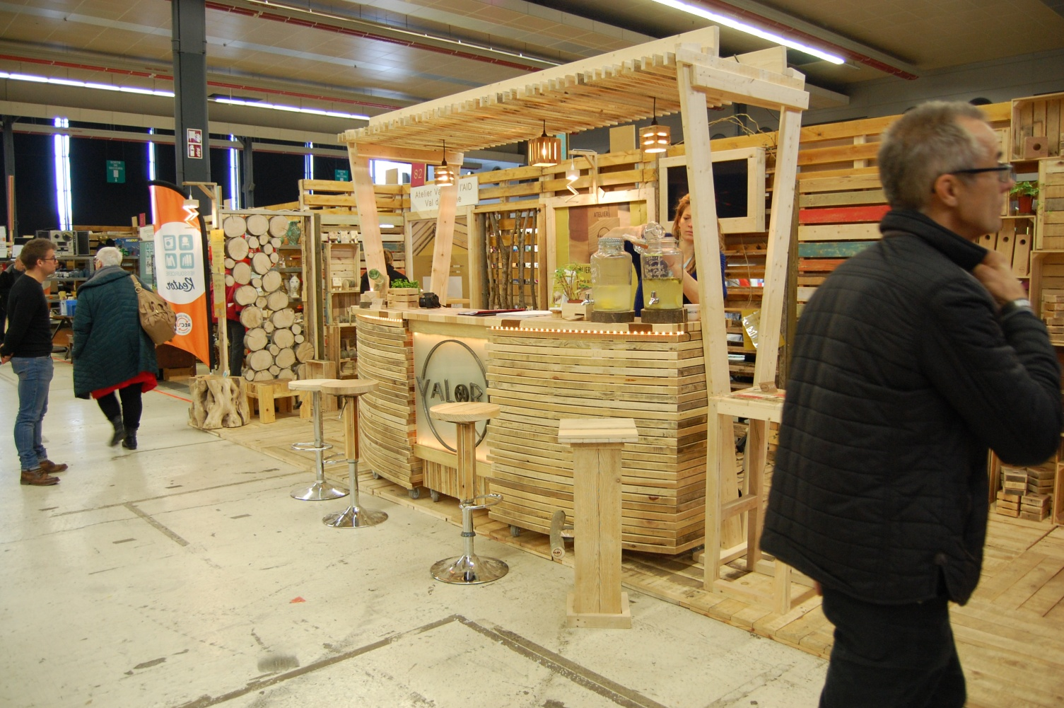
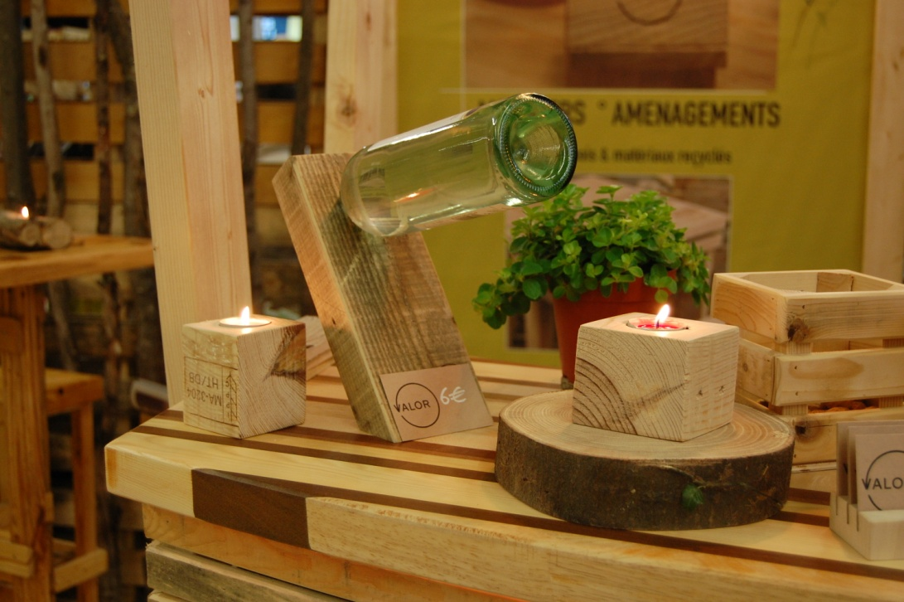 |  |  | Brief description:  The public of the Récup'Ere fair is a public concerned by recovery and reuse problem, even if some people, less aware, come "as tourists".  Nevertheless, access to the various workshops  organized during the show are intended to make them aware of the aspects of recovery, reuse and revaluation.  The participation of the City of Namur, self-proclaimed "capital of reuse" is a plus for the dissemination of ideas, supported by a public authority invested and which itself raises awareness among its population.  The BEP (Intercommunale de développement économique de la Ville de Namur) is also an important driver for the dissemination of the principles of waste reduction, reuse, reuse and recycling of objects.
Impacts/opportunities for local partners – participants - territory :
- Récup'Ere fair is the ideal place to illustrate the EWWR.
- In a single place, most of the actors (in Wallonia) active in recovery, reuse, repair and who are also active in the propagation of the circular economy principles are gathered.
- These actors are also committed to spreading the use of the second hand (recovery/reuse) that is, in terms of quality, as safe as manufactured products. Thanks to the Fédération Ressources, most of them adhere to quality labels such as Rec'Up, electroREV, Solid'R.
- They are all campaigning for a world that is more respectful of the planet, favouring short circuits and the circular economy principles.

Dissemination/visibility:
- Many announcements are made to attract the public :
- http://www.recupere.be/
- https://www.namurexpo.be/fr/Calendrier/2018/recupere
- https://www.facebook.com/LEntrePotNamur/
- https://www.namur.be/fr/agenda/recupere/event_view
- https://www.bep-environnement.be/actualites/salon-recupere-stand-bep-zero-dechet-et-conferences-de-sylvie-droulans/
- https://www.out.be/fr/evenements/544104/recup-ere/
- http://www.dewolfs.be/recupere/
- https://www.rtbf.be/auvio/detail_les-salons-zero-dechet-et-recup-ere?id=2417404
- 150 exhibitors

