Name of the Good Practice (give a title of 5 to 6 words max): The Repair Cafés are independent, public and free events, organized by volunteers. The main goal is to Re-valorize objects. | Contact:  Name: Marta Brazão  Address:  Mail: repaircafelisboa@gmail.com
Domain concerned:  ☐ Good Practice - General  ☐ Good Practice - Collection  ☒ Good Practice - Valorization | ☐ Good Practice - Sale  ☐ Good Practice - Sensitization

Implementation context (territory, starting point, ...)
Lisbon but they intend to spread the concept to Torres Vedras and Oporto.
Practice, method of intervention and objectives of the approach
Every month a team of volunteers joins the Repair Café to fix objects, like electronic, cloths or household appliances. The events are free and open to the general public. The idea is valorising old objects and also share knowledge of how to re-valorise other objects in the future.
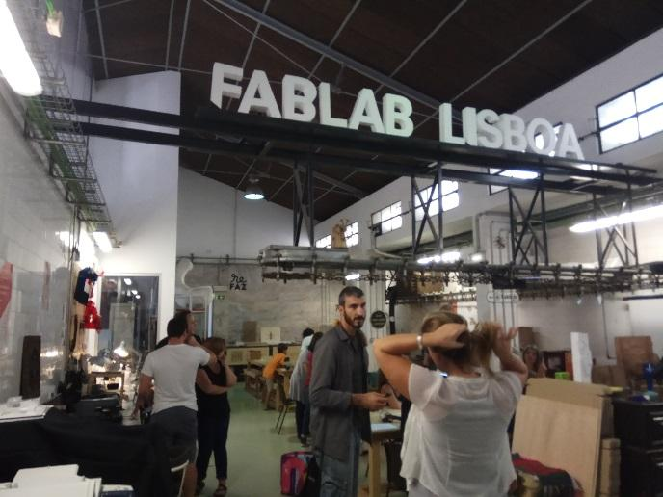
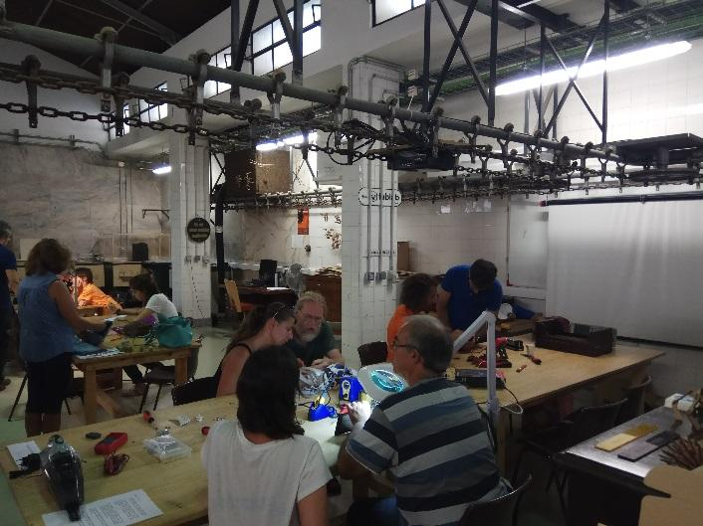

Results (impacts on the public, the territory, ...)  Make general public aware, promote valorisation of goods, stimulating the transition from a linear to a circular economy. | Target audience:  Local residents if Lisbon
Perspective of use and dissemination:
This activity will be disseminated in the website of ISQ, as an action included in the EWWR.

