Name of the Local event:  Open event cleaning Arinella beach |  | Contact: Edita Raffaelli  contact@ec-corsica.eu
Period:  every Wednesday on the period from April to September 2018 | Target group:  Workers in professional inclusion scheme | Objective:  Sensitize the local people on the importance of cleaning the beach.
Programme of the 6th of June, public day of the cleaning activities

09:00 A demonstration of the weekly activity of cleaning and sorting waste from the lumbers.
09:30 Press release with interviews and video Recording.
10:00 Presentation of the Co-creative project and all the intellectual outputs produced so far with a focus on the curriculum.
10:30 New ways for the reuse of the woods: ex. Creating sculptures with the wood recovered, building a path with the anthropogenic waste etc…

Partners involved in the organisation:

- Bastia city hall. The local authority of Bastia gave the permission for doing the cleaning activities every Wednesday on the public beach to ECC’s workers in inclusion schemes. They have a large panel of competencies in all fields. Its scope, in the Co-creative youth context, is to promote sustainable development activities in the city.
- Coastal conservatory of Corsica The Corsican Coastal conservatory give his support for the organisation of this activity.
- Etudes et Chantiers. Etudes et Chantiers Corsica is one of the Co-creative youth consortium partners and represents the French delegation lead by Office de l’Environnement Corse. Their staff has key competencies in professional training trough sustainable development activities and collaborates with the Bastia local authority.

Implementation context  As part of the reasoned cleaning of the Arinella beach, the Etudes et Chantiers team, partner of the Co-Creative Youth consortium, is mandated by the city of Bastia with the technical support of the Conservatoire du Littoral of Corsica to carry out the selective sorting of anthropogenic waste collected on the beach, lay out ganivelles to allow the dunes to re-establish themselves and to sensitize the general public to the importance of the preservation of the site. This action takes place every Wednesday during the summer season from April to September 2018. |  |  | 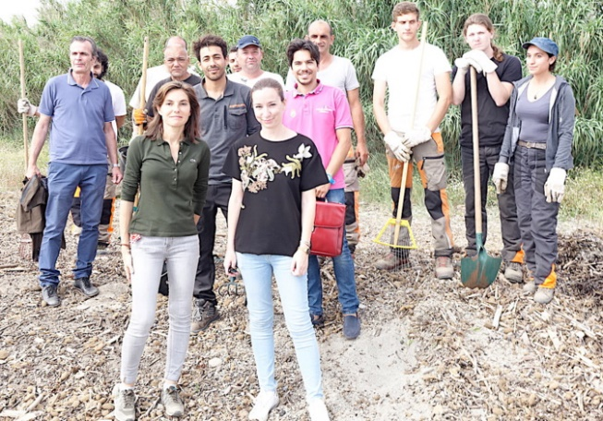
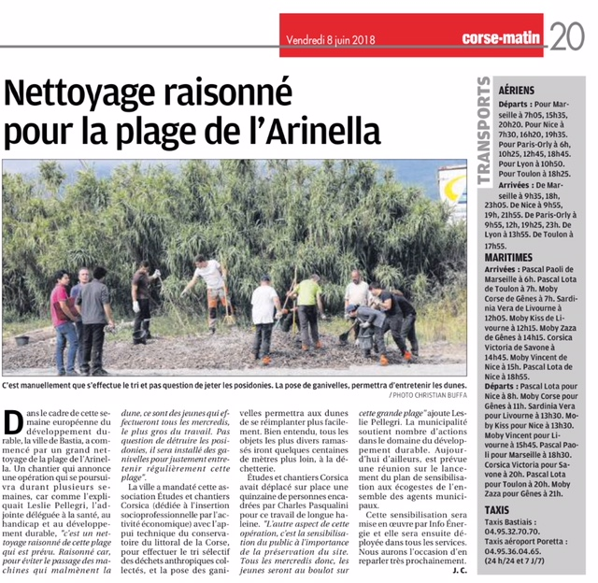 |  |  | Brief description:  The 6th of June 2018 the professional inclusion training and awareness raising event took  place at Arinella beach at Bastia: a "citizen cleaning" for a clean beach on the southern part of the Arinella.  This day was a perfect opportunity to move from theory to practice by attacking the cigarette butts, plastics, paper and other waste that litter the beach. Objective: to raise awareness among the younger generations of the challenges of the environment and nature conservation.  This action contributes to sustainable development because the idea is to restore the wild aspect of the beach. Waste collection and sorting also contributes to sustainable development.
Impacts/opportunities for local partners – participants - territory :

The target group is the trainees and the employees involved in the professional inclusion training pathway and the passer-by’s.
The Arinella beach cleaning from April to September represents a great opportunity for people in professional inclusion schemes as well as for the whole local society. This represents a starting point for a sustainable partnership.
Moreover, the municipality does not intend to confine these initiatives to Arinella beach: in the coming weeks, a major awareness campaign on the cleanliness of the city should be implemented in the neighbourhoods.
There are opportunities for future collaboration within the duplication of Cocreative project’s trainings in Bastia and in the Corsican territory between the Bastia city hall, Etudes et Chantiers Corsica, Office de l’Environnement Corse and the associated partners (Initiativa, Corse Insertion, Recyclerie de Calvi).

Dissemination/visibility:

We registered a high participation of stakeholders (several members of the city of Bastia), the local television, two local newspapers and an interview for the local radio broadcast station.

At European level, the event and the cycle of weekly activities were spread on the European Sustainable Week website.
https://positivr.fr/nettoyage-arinella-developpement-durable/
https://www.oec.corsica/attachment/1029596/

