Name of the Good Practice (give a title of 5 to 6 words max):  Bordallo II is a Portuguese artist. He was born in Lisbon, 1987. This is how he presents himself: “I belong to a generation that is extremely consumerist, materialist and greedy. With the production of things at its highest, the production of "waste" and unused objects is also at its highest. "Waste" is quoted because of its abstract definition: "one man's trash is another man's treasure". I create, recreate, assemble and develop ideas with end-of-life material and try to relate it to sustainability, ecological and social awareness”. | Contact:  Name: Bordallo II  Address: http://www.bordaloii.com/  https://www.facebook.com/BORDALOII/  Mail: bordalo2nd@gmail.com
Domain concerned:  Good Practice - General  Good Practice - Collection  Good Practice - Valorization | Good Practice - Sale  Good Practice - Sensitization

Implementation context (territory, starting point, ... ..)
The artist work of Bordaloo II is spread around the world:
https://www.google.com/maps/d/u/0/viewer?ll=35.65505519025667%2C-9.40059346542887&z=3&mid=1RXQfYhf5qWNoFcMpOV8XZspCBGs

Practice, method of intervention and objectives of the approach
He creates urban art from waste, with great visual impact. Huge animals or figures build from metal, plastic and other materials, impose their presence.

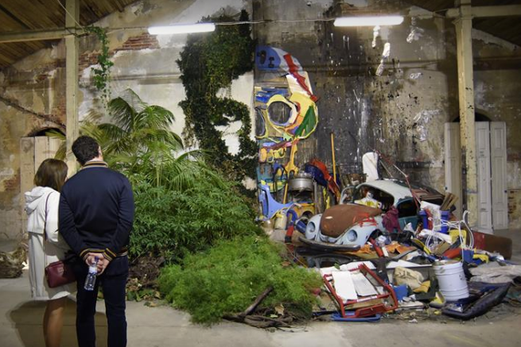

Results (impacts on the public, the territory, ...)  A way of educate and raising environmental awareness through art. | Target audience:  General public.
Perspective of use and dissemination:
ISQ will be present on November 19th on the exhibition ATTERO by BORDALO II and will explore dissemination opportunities. The artist will carry a workshop for underprivileged children and youngsters.

