Name of the Local event:  “Waste Travel 360 °” |  | Contact:  ASEV – Agenzia per lo Sviluppo Empolese Valdelsa  info@asev.it
Period:  31 May 2017 | Target group:  Students of the Secondary School Busoni-Vanghetti | Objective:  This initiative aimed to stimulate a reflection on issues of sustainability and good waste management so that young people can become more responsible citizens and consumers. To do this, an innovative tool was chosen that cleverly joins the game and new technologies to tell what happens after separate collection, bringing students "directly" to the workshops to show them the paths of valorization and transformation of the various materials. In this way, we aim to make young people acquire new awareness: waste is not a disadvantage but valuable resources from which new material can be obtained.
Programme:

The event was repeated twice on the 31st of May: from 10.00-12.00 for one class and from 14.00-16.00 for another class

Partners involved:

- Municipality of Empoli represented by Fabio Barsottini (councilor for the environment)
- Alia Servizi Ambientali S.p.A. (a Tuscany environmental service management company) represented by Chiara Fiorentini (REC - External Relations and Communication Service)
- Secondary school Busoni-Vanghetti represented by Grazia Mazzoni (dean).

Implementation context (territory, starting point, ...)  The event was organised in ASEV’s premises in Empoli (Italy) during the European Sustainable Development Week 2017 |  |  | 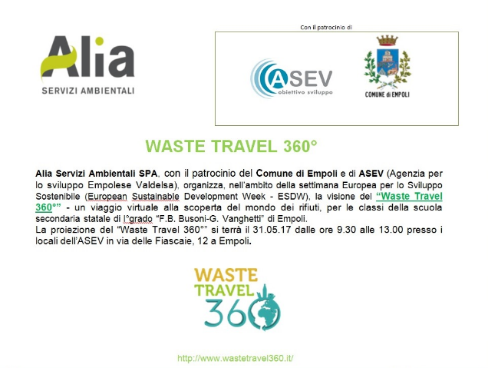
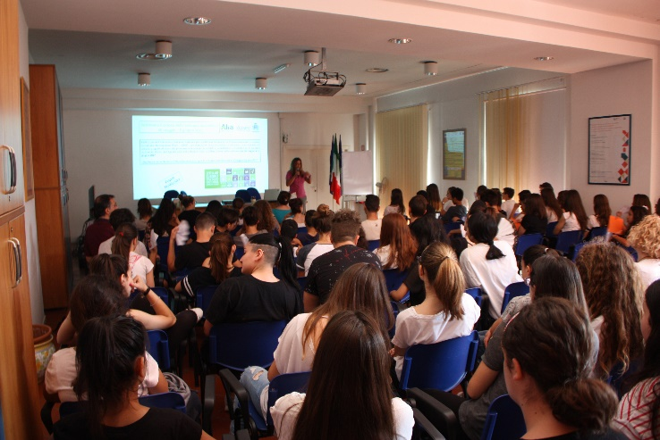 |  |  | Brief description:  During the meeting, held at the ASV multimedia room, the students discovered the 360 ° Waste Travel, the virtual game created by Ancitel Energia & Ambiente and sponsored by ANCI (Italian Municipal Association) and the Environment Ministry, which allows young users of Make an interactive visit to the world of waste and the circular economy.  Like in a video game, students were able to interact directly with materials, from organic to paper, from glass to plastic packaging, following the entire life cycle from differentiated collection, to the process of enhancement to the transformation into new products.
Impacts/opportunities for local partners – participants - territory:

Students of two classes of the secondary school Busoni-Vanghetti (totally 60 persons) were sensitied for the correct recycling and reuse.

Dissemination/visibility:

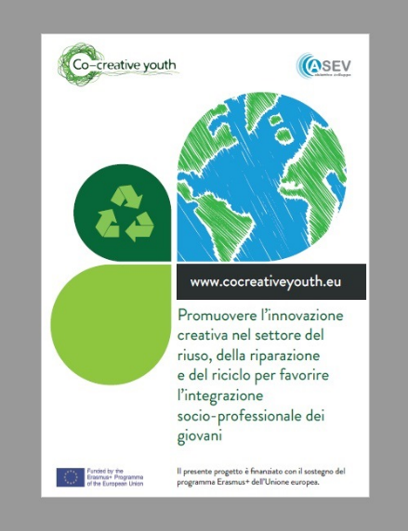
The communication activities were divided to the pre-, during- and post-event. The pre-event activities were aimed to announce the event, and more widely raise awareness about the project. Such activities included:
- a tweet on ASEV’s account: https://twitter.com/agenziasviluppo
- news on Facebook page of the project Co-creative youth
- registration of the event on the EWSD website: http://www.esdw.eu/country/italy/
- creation and publication of the promotional e-flyer of Alia and Municipality of Empoli
During the event the participants were informed about the project by:
- espousing a poster about the project
- distribution of the flyers
The post-event activities were aimed to report the event and disseminate its results, and more widely to sensitize the general public regarding the recovery, repair and re-use. Such activities included:
- news on the Facebbok page of the project co-creative youth
- A press release on the website of the Municipality of Empoli http://www.comune.empoli.fi.it/comunicati/index.asp?INCLUDI=2017/5/rifiuti.htm
- One article on Gonews (local level) http://www.gonews.it/2017/05/31/riciclo-ed-economia-circolare-gli-studenti-delle-busoni-vanghetti-lezione-alia/

