Name of the Local event:  “New life of old things” |  | Contact:  ASEV – Agenzia per lo Sviluppo Empolese Valdelsa  info@asev.it
Period:  05 June 2018 | Target group:  Wide public | Objective:  To demonstrate to the wide public that the creativity on how to reuse the things that are not used any more is within everyone's reach and in this way to boost domestic reuse and recycling
Programme

An exposition that took place on the 5th of June 2018 from 15.00 till 18.00

Partners involved in the organisation:

The event was organised by ASEV without involving any local partner

Implementation context  The event was organised in ASEV’s premises in Empoli (Italy) during the European Sustainable Development Week |  |  | 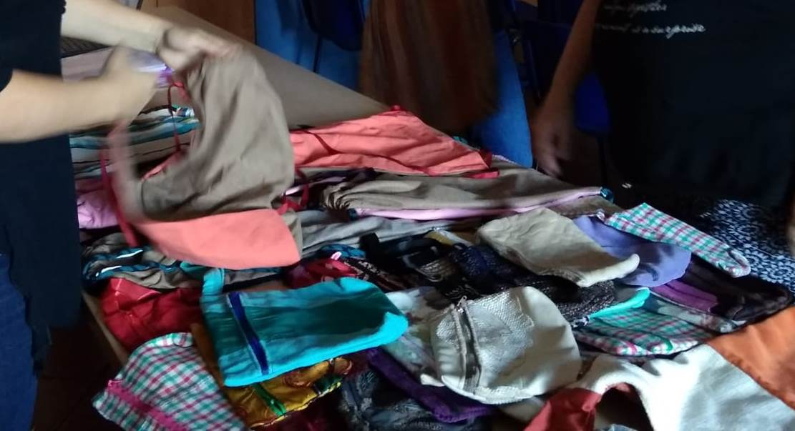
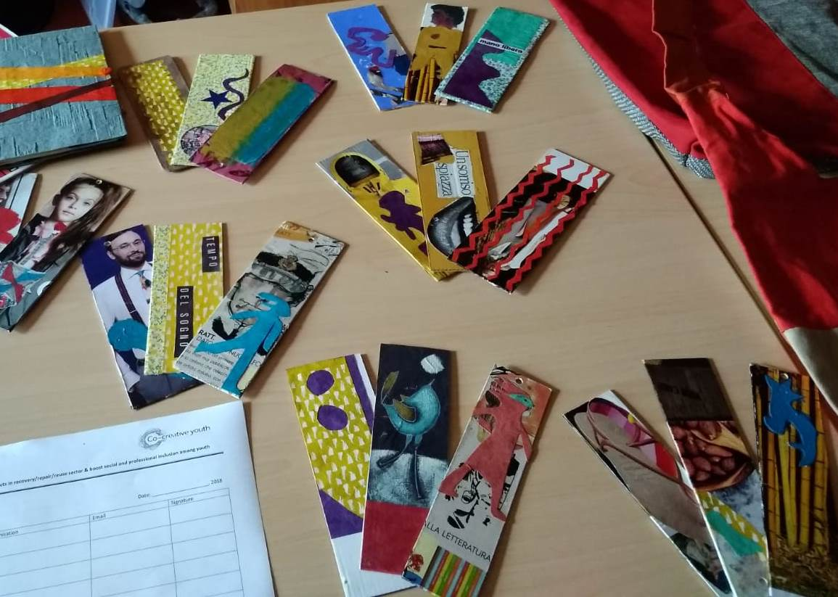 |  |  | Brief description:  The event was organised in form of an exposition of the products created by the refugees from the materials recovered from the old things. The event was opened to the wide public.
Impacts/opportunities for local partners – participants - territory:

The impact regarded mainly two main aspects:
- the visitors of the exhibition had an opportunity to learn that a lot of new things can be created by using the materials recovered from the old not any more useful things
- the refugees, who created the exposed products, were encouraged to continue their creative reuse activities

Dissemination/visibility:

The event was registered on the website of the European Sustainable Development Week:
https://www.esdw.eu/country/italy/

