Name of the Local event:  Lectures with a thematic video presentation for teens |  |  | Contact:  ASEV - Agenzia per lo Sviluppo Empolese Valdelsa  e.constantinova@asev.it
Period:  - 19/11/2018  - 22/11/2018 | Target group:  - 18 students 16-18 years old who dropped-out school and now follow the ASEV professional training course "Bar Room Attendant".  - 17 students 16-18 years old who dropped-out school and now follow the ASEV professional training course "Sales clerk". |  | Objective:  Inform and sensitize teens for the correct separate collection of waste and its reduction
Programme

- 19/11/2018 (Lesson from 10.00-11.30):
- 22/11/2018 (Lesson from 14.00-15.30):

Partners involved in the organisation:

ALIA S.p.A (a public waste collection and disposal company) represented by Mazzioli Sergio (Responsible for the Ambient education department of Florence).

Implementation context  The events was organised in Empoli (Italia) during the European Week for Waste Reduction. |  | 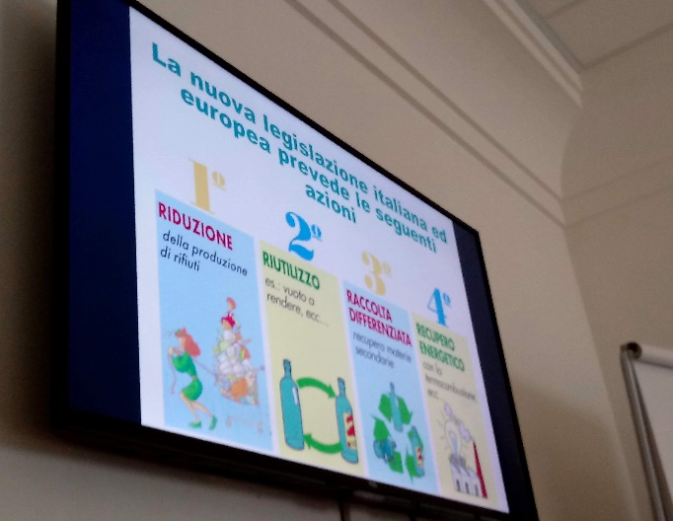
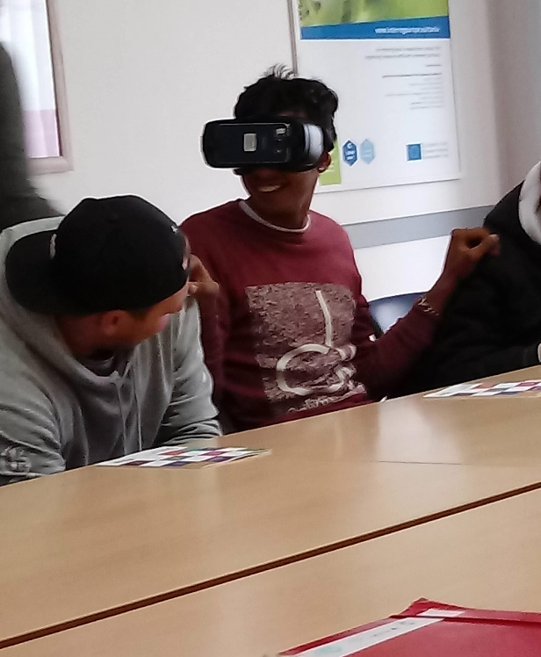 |  | Brief description:  The both lessons were carried out by the following scheme:  - initial presentation on the theme of the waste management and recycling,  - virtual tour to the waste recycling plant with use of the particular equipment  - discussion, questions and answers
Impacts/opportunities for local partners – participants - territory:

35 disadvantaged teens formed on the topic in an entertaining way what let sensitize them better for the correct separate collection of waste and its reduction.

Dissemination/visibility:

The event was registered on the website of EWWR:
http://www.ewwr.eu/actions/project_archive_new/lectures-with-a-thematic-video-presentation-for-teens

A Tweet was published on the ASEV account
https://twitter.com/agenziasviluppo/status/1064561743974805506
An article was published on the Facebook of the project Co-creative youth
https://it-it.facebook.com/cocreativeyouth/

