Name of the Local event:  Environmental Sensitisation for Infernal Staff at ISQ Training Centre |  | Contact:  Lara Ramos  loramos@isq.pt
Period:  EWSD  30th May-5th May 2017 | Target group:  ISQ staff  ISQ trainees & trainers | Objective:  - Presentation of the Co-creative Project: aims and possibilities of implementation;  - Presentation of the EUROPEAN SUSTAINABLE DEVELOPMENT WEEK;  - Environmental awareness, waste separation and another “green” practices to be effectively implemented at ISQ Training facilities.
Programme

- Co-Creative Erasmus + project: aims, IOs vantages for ISQ and ISQ stakeholders
- What is the EUROPEAN SUSTAINABLE DEVELOPMENT WEEK? Why are we here?
- The plastic island – consequences
- How / why separate waste?
- Q&A
- Brainstorming / hands on session – How can ISQ become more “green”?

Partners involved in the organisation:

No external partner was involved.

Implementation context  - ISQ Internal event. |  |  | 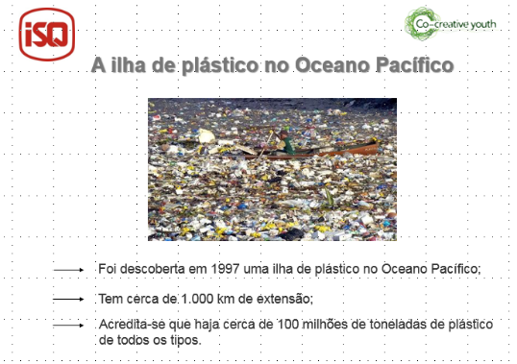  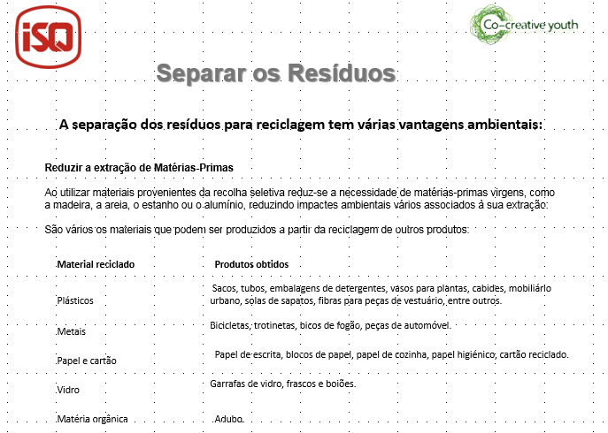
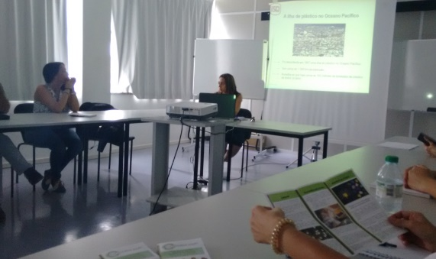  From this event, some green initiatives came to life, by brainstorming:  - a non-plastic Christmas tree made from welded pieces (re-using metal plaques) in collaboration with the welding students and the welding ISQ school;  - waste separation improvement at ISQ training facilities: enforcement of trash cans for plastic, glass, paper and organic waste & use of infographics;  - re-using toys initiative: ISQ staff brings used toys (in good conditions) to being collected and distributed to local associations such as “Casa da Criança de Tires”;  - CSR initiatives involving ISQ volunteers (staff) collecting waste from local beaches (see EWWR 2018 ISQ event). |  |  | Brief description:  All ISQ Training facilities staff (administrative & trainers) were invited to attend this event.  The main objective for this day was to sensitise the public for the importance of the sustainable development. ISQ, as a company, has the CSR to stand for sustainable development, promoting environmental awareness and supporting green initiatives. This must come from inside to outside so, ISQ decided to start this first EWSD, supported by the Co-Creative project, to sensitise its own public: the “internal stakeholder”. This was also an opportunity to the R+I Training Sector present the Co-Creative Youth project to the rest of the internal staff.  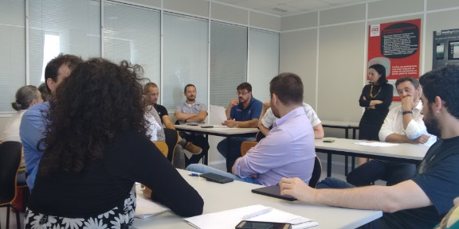
Impacts/opportunities for local partners – participants - territory:

From this event were born several “green” initiatives – more effective waste recycling, re-using of waste and life cycle extension. Partnerships were established with some social organisations who support disadvantaged children, such as “Casa da Criança de Tires” and “Associação CrescerSer – Associação Portuguesa para o Direito dos Menores e da Família”. These organisations benefited directly from these new approaches. This was also a moment to present the Co-Creative project and brainstorm with the internal staff about the most effective ways to implement and disseminate the project outcomes.

Dissemination/visibility:

ISQ Internal Website - http://site-interno.isq.pt/
Social networks - https://www.facebook.com/isq.formacao
Internal mailing list

