Name of the Local event:  ECO CODE SESSION |  | Contact:  Lara Ramos  loramos@isq.pt
Period:  30th Mai-5th June 2018 | Target group:  ISQ apprenticeship classes | Objective:  This activity, integrated into the Co-Creative Youth Project, aims to involve all ISQ Apprenticeship classes, by writing an ECO-CODE, to create environmental awareness inside ISQ Training Department.
Programme

- Video “Circular Economy – Cradle to cradle”
- Kahoot game
- Webquest: Let’s write an Eco-Code
- Practical sessions – build an Eco-code from recycled materials

Partners involved in the organisation:

No external partner was involved.

Implementation context  Internal event for ISQ Apprenticeship classes. |  |  | 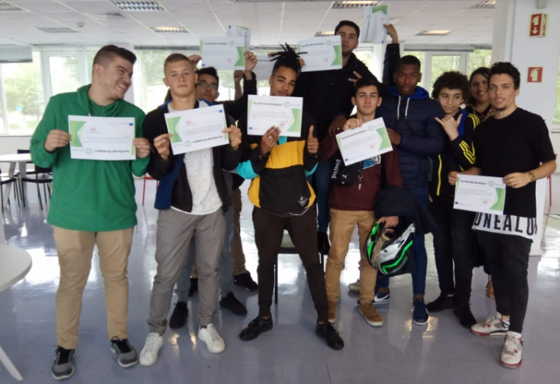
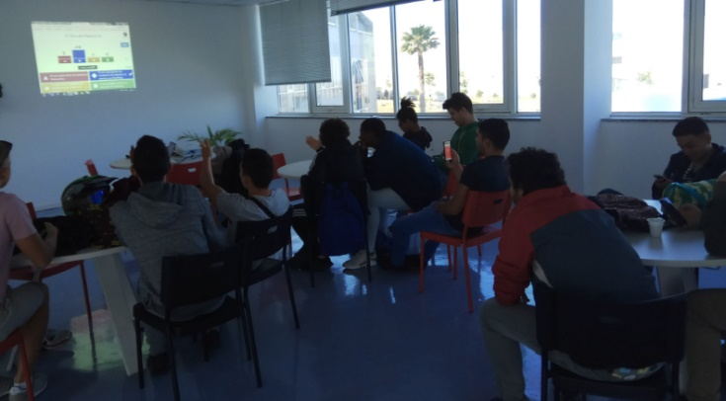  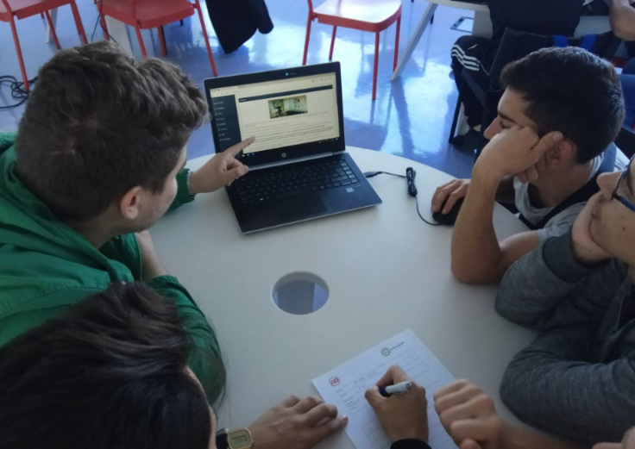  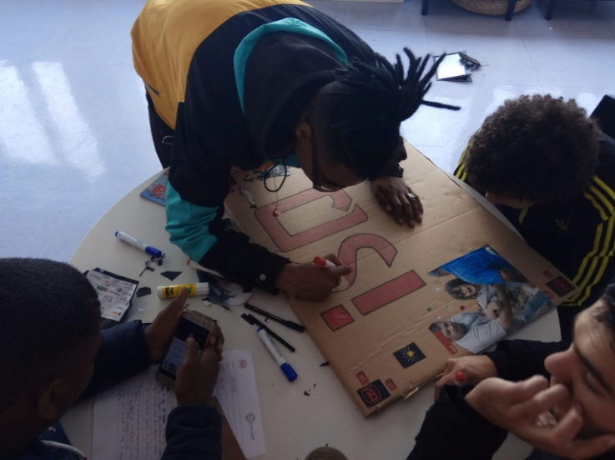 |  |  | Brief description:  Apprenticeship classes were invited to write an Eco-code to be implement at ISQ Training Facilities. Through gamified approaches, students met the objectives of the session integrated into the EWSD.  The session started with a video - https://www.youtube.com/watch?v=zhFhgXb4hO4 – about CE. Students were invited to brainstorm about it.  A Kahoot - https://play.kahoot.it - game was planned in order to measure their knowledge on CE subjects – this was also a way to measure the effectiveness of the ongoing Co-Creative pilot sessions.  The second phase of the activity was related to the ECO-CODE. A webquest designed for the effect was written and students followed the instructions and wrote the ECO-CODE in small groups.  The third phase was dedicated to design the ECO-CODE from recycled materials that they personally collected.  The ECO-CODES produced are now exposed at ISQ Training Facilities, to be read by internal staff and clients.
Impacts/opportunities for local partners – participants - territory:

Involving trainers, trainees and ISQ staff working all together to change mind-sets and behaviours is very important for ISQ. Impact in the organisation has been slow but effective. In the end, we must be an example for clients and young trainees. From this event was born the #OMundomudacomoteuexemplo (#the world is your example). This is now the motto for every ISQ CSR actions, namely, environmental ones. A proposal was made to the Human Resources Department and by the occasion of the European Week for Waste Reduction 2018 ISQ volunteers decided to start to clean beaches all together, involving two Municipalities and Environmental Associations (see EWWR 2018 ISQ event).

Dissemination/visibility:

ISQ Internal Website - http://site-interno.isq.pt/
Social networks - https://www.facebook.com/isq.formacao
Internal mailing list

