Name of the Local event:  Business volunteering action: cleaning beaches |  | Contact:  Lara Ramos  loramos@isq.pr
Period:  29th October -26th November 2018 | Target group:  ISQ Staff | Objective:  Cleaning local beaches near ISQ facilities at Oeiras and Grijó (Vila Nova de Gaia)
Programme

Starting from 29th of October and every Mondays following, from 9h30 to 16:30 volunteers join all together to collect waste from local beaches.

Partners involved in the organisation:
- Municipality of Oeiras
- Oeiras Solidária - Social department of the Municipality of Oeiras
- ELA - Estação Litoral da Aguda – through a protocol with the Oporto University, this aquarium – owned by the Municipality of Vila Nova de Gaia - promotes environmental education related to the ocean and beaches.

Implementation context  Involvement of ISQ staff, municipalities and environmental associations from Oeiras and Vila nova de Gaia regions. |  |  | 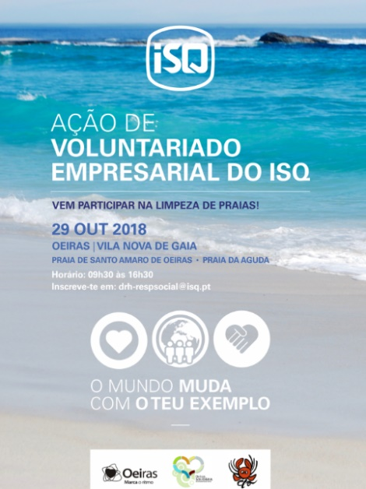
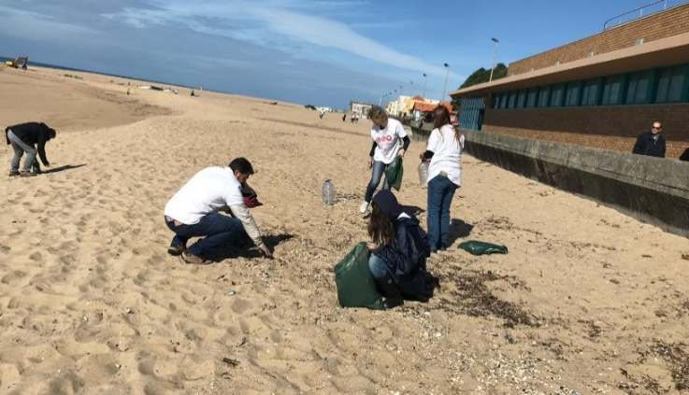  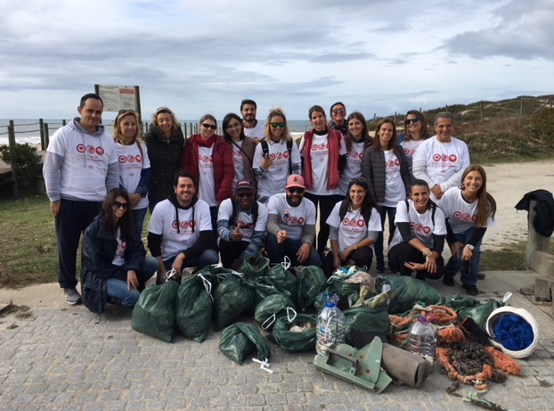 |  |  | Brief description:  Following the success from the first two Territory Animations – “Environmental Sensitisation for Infernal Staff at ISQ Training Centre” and “Eco_code; under the motto #OMundomudacomoteuexemplo (#the world is your example) ISQ went further and decided to start a new volunteering action, inspired by the Co-creative Project and the European Week for Waste Reduction.  ISQ volunteers joined all together to clean beaches near ISQ facilities: Santo Amaro de Oeiras beach and Aguda beach, supported by the Municipalities of Oeiras, Vila Nova de Gaia and Estação Litoral da Aguda aquarium.
Impacts/opportunities for local partners – participants - territory :

This is events had great success near the ISQ staff and local public. From ISQ example anonymous citizen started to join the
and more events are planned for 2019. ISQ pretends to extend this action to other beaches nearby.

Dissemination/visibility:

ISQ Internal Website
ISQ External Website
Social networks from ISQ, Oeiras Municipality, Vila Nova de Gaia Municipally and Estação Litoral da Aguda
ISQ Internal mailing list

