Name of the Good Practice (give a title of 5 to 6 words max):  Change the world with style | Contact : Lisa Bläckt  Name:CorneliaSun  Address: Sankt Eriksgatan 63B, 112 34 Stockholm  Mail: info@corneliasun.se
Domain concerned:  Good Practice - General  Good Practice - Collection  Good Practice - Valorization | Good Practice - Sale  Good Practice - Sensitization

Implementation context (territory, starting point, ... ..)
Cornelia Sun is a lifestyle brand that launched in the summer of 2014 and the concept behind this colorful label is sustainable responsibility and global consideration. This colorful collective is designed in Sweden, made in Nepal and created by two sisters who find true reward in transforming various sources of inspiration into exclusive eco-friendly clothing. The spellbinding design is the result of an elaborate combination of impressions, a mix of energies where the wild encounters a state of peace – a tribute to Mother Earth and all her people.
Cornelia Sun often is recognized for colorful and oversized kimonos with the bohemian flair and with touches of both elegance and playfulness. The sisters behind this conscious movement believe that exclusive wear should be affordable, sustainable and a way for you to express yourself. Every single item is a one-of-a-kind made from up-cycled textiles that previously have been worn as saris by women in Eastern Asia. Each print tells a story and your global sister's memories and experiences lay within these threads. The aspiration with these clothing line is for you to continue her journey and become a co-creator.
Dress up for change and always remember – what we share is more powerful than what divides us

Practice, method of intervention and objectives of the approach
CLOSING THE LOOP
Our mission is to close the loop in everything we do. To us, it is important to give love in return to both Mother Earth and her people. All our consistent designs are made from material that previously have been worn by women as traditional saris in Eastern Asia. Our love for this region is deep and pure and our hearts are forever connected to the places we´ve seen and to the people that we´ve met. All our garments originates from this part of the world and this is where the first chapters were written. It is time for us to give back – and make history by creating a future for everyone.
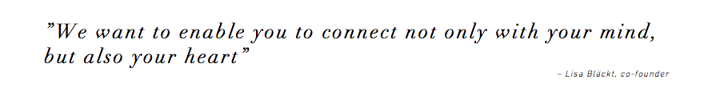
We know there are many things that could need support and of course we would love to help in all these different categories. The thing is though, that energy flows where attention goes and our hearts sing a little extra for our global sisters. Over and over again, we see that when women succeed, communities succeed. According to this background our main goal is to support initiatives that aim to empower women. The projects we work with are put forward by our amazing impact partners. To us, it is important that we have full insight in the projects that we are supporting and we want to participate ourselves to make sure it consonance with our intention. We only partner with organisations aligning with our core impact values to fund sustainable projects that empower communities and create real lasting change. Education and the transfer of skills are therefore at the core of every program we fund. Our engagement has a holistic approach and it covers both physically, socially, financially and spiritual aspects. Our commitment is always locally rooted and we only partner with non-political and non-religious organizations with long lasting ambitions. We are convinced that the more love there is – the greater impact.

Results (impacts on the public, the territory, ...)  WHAT WE DO IN INDIA  Since day one, Cornelia Sun has supported a local non-profit organization in India called the AVI (learn more). We choosed to partner with this organization because we´ve been participating in the project two month ourselves (2014). This experience gave us the knowledge and insights we needed to involve Cornelia Sun in the program. Above all, we now know the positive difference contributions can make for the people involved.  AVI is a grassroots organization primarily being run by volunteers and it is based in a small village in the Northern part of India called Sikar. The main goal is to provide, personal growth, safety and fun in our programs that are included in the projects for the various fields. Sustainable development of a community or society along with the family could be achieved on the basis of the fact that there is no tool for development more effective than the empowerment of women. In this part of India, women do often have no earnings and therefore they remain dependent on their family for livelihood and this is the main reason why they are not provided with equal rights. Women are also the victims of domestic violence because they have limited access to several important resources and employment opportunities. The thing that can help the women to live a dignified life and protect themselves from domestic violence is empowerment and it is must to be provided to them. And this is where you come in.  DRESS UP FOR HER  The volunteer program in India as offered by AVI for women empowerment is developed so as to help women become self independent. These women in this area were born into a low cast community of poverty and are treated with little respect and acceptance by others members of society as well as public authorities. They are deprived of basic human rights and have never been able to go to school in their younger years. To make sure Cornelia Sun constantly support the young girls and women each purchase matters. Based on revenue we have contributed with financial support to make it possible for AVI to hire teachers who can teach hindi and help the volunteers with the daily work. When you dress up in your unique print of art you automatically give the village's women the opportunity to learn how to write and count, along with the opportunity to develop their own creative skills by providing with material for sewing and jewelry making. Above all, we are also proud to announce that AVI (2015) finished the construction work of a boarding house only for girls which will give our global sisters the opportunity to fully focus on their studies. The mission is to encourage girls to invest in their right to education and empower them to live their dreams. | Target audience:  Women around the world, both for dressing up in upgraded clothes and for women in parts of the world that can work themselves out of poverty.  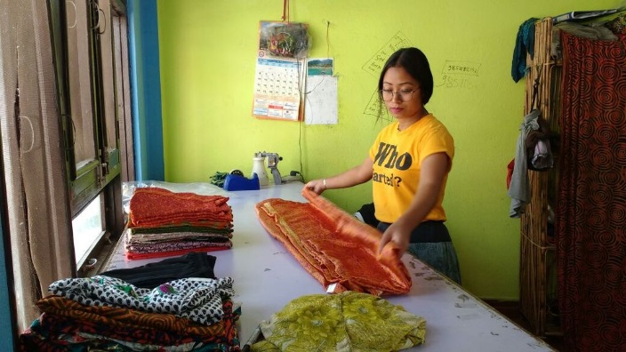  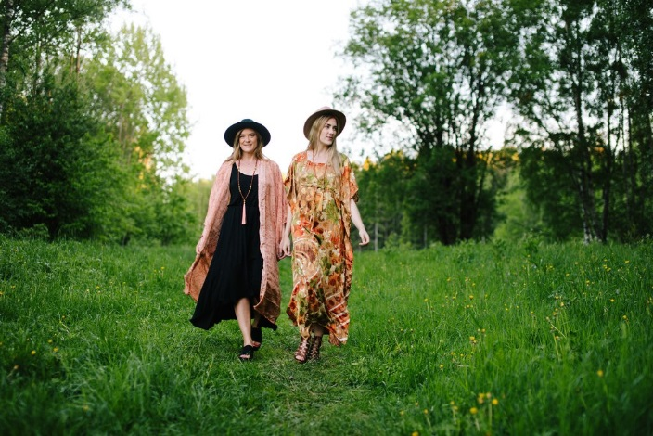
Perspective of use and dissemination:
A initiative both for fashion and for women to women perspective

