# The Sustainable Square – a cooperation between municipalities, private companies, municipality companies and interested actors

## Background

The municipality of Gävle is working hard to become the most sustainable municipality in Sweden. The municipality has built an area for athletic stadiums and were planning a opening ceremony. It was a perfect place for showing all aspects of the work that are going on in the region and where we are aiming for 2030. The thematic would be in seven areas.

* The capital of GIS
* The logistic center
* The welfare square
* Innovation square
* The event square
* The good life in Gävle 2030
* The sustainable square

The focus in this example will be The sustainable square.

## Purpose for the sustainable square

To have an arena, where there are a lot of people visiting, to show the whole perspective of sustainability in the municipality

## Goals for the sustainable square

* To show the sustainable Gävle for the inhabitans.
* To give a view of Gävle 2030
* To have a cooperation between municipality, municipality companies and private companies.
* To show different aspects of sustainability
* The transport: walking, bicycling, public transport, car pools and a city with just renewable fuels (biogas, electricity and HVO)
* The food: more produced in the close area, more ecological, more vegetable, more season grown
* The living accommodation: low energy consumption and renewable, local production of electricity and fuel.
* The shop and shopping: buy quality and less, don´t use chemicals and ask if clothes contains dangerous chemicals, reuse, recycle and be innovative

## Planning for the sustainable square

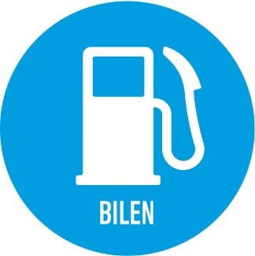

The new electric bikes, the local bus company showing the biogas buses, the new renewable cars in the municipality, the project about transportation together, the car pools, the HVO diesel, the biogas and the new cycle lanes



Local production of food, vegetarian food, local restaurants and recipts.

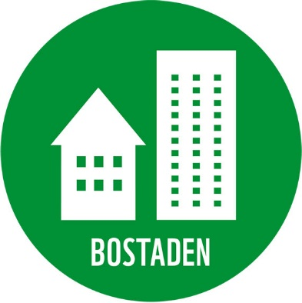

Sustainable building, water protection and saving water, energy consulting, sun cells other renewable energy sources, district heating, ground heating.



This one is shown more exactly in the file.

## Practical performance

The exhibition was arrange in the indoor stadium for the track and field. Every square had their exhibition area and also space outdoor. The sustainable square is the one marked with a circle and all the above parts where in that area.

* It´s important that every subject has it´s own responsible project leader.
* Try to find both private and municipality actors.
* The marketing of the event is important. Make a communication plan.
* 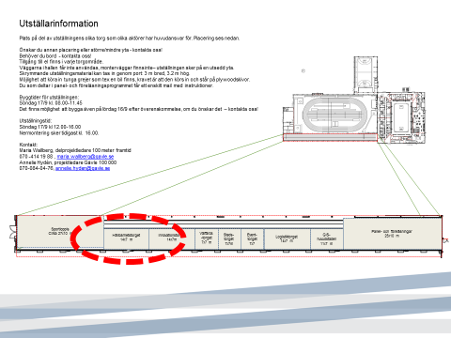

## Result

More than 20 actors were involved in the sustainable square. Over 1000 inhabitants were attending the exhibition.