Name of the Good Practice (give a title of 5 to 6 words max):  The banana bus – drives on your banana peel | Contact :  Name: Gästrike återvinnare  Address: Utmarksvägen 16 801 28 Gävle Mail: info@gastrikeatervinnare.se
Domain concerned:  Good Practice - General  Good Practice - Collection  Good Practice - Valorization | Good Practice - Sale  Good Practice - Sensitization

Implementation context (territory, starting point, ... ..)
In order to minimize the burnable waste and use the food waste as a resource for bio fuel (veichle gas methane) and bio digest (nutrients for cultivating). A bus is striped and the people using the bus is informed by communicators and get healthy bananas to eat and then throw in the recycling paperbag.
Practice, method of intervention and objectives of the approach
- Cooperation between bustransport company, Nettbus, the waste management association, Gästrike återvinnare and the food waste treatment company Ekogas.
- The main objective was to make people be aware of what small amount of food waste needed for transporting a bus 1 km.
- To make people discuss sorting and why it´s important.
- Catch up questions from the public about environmental issues

Results (impacts on the public, the territory, ...)  +++  - It was a good arena to inform, discuss and show the public about sorting, recycling and reuse. Many of the travelers were glad to have ous on the bus and said we made the atmoshere light and friendly.  - The media made a reportage on the radio.  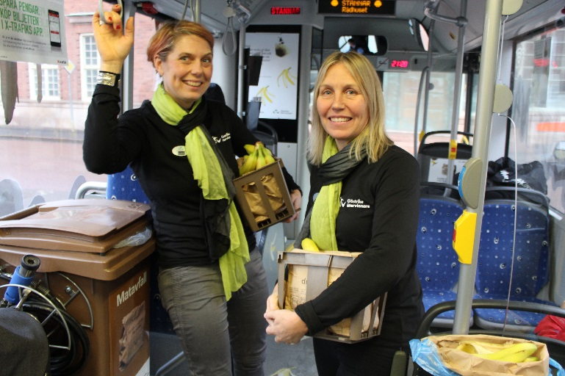 | Target audience:  Public, people travelling with the bus (Biogas bus)  Media  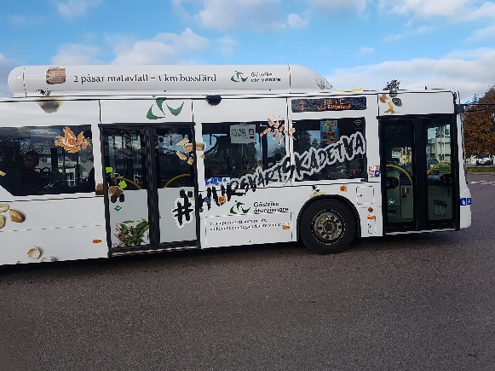
Perspective of use and dissemination:
This is just a parto fmaking people aware of the waste hierarchy and their own possibility to be a part of the change.

