Name of the Good Practice (give a title of 5 to 6 words max):  Shopping second hand in a mall | Contact : Eskilstuna Energi och miljö  Name: REtuna  Address: Folkestaleden 5, 635 10 Eskilstuna  Mail: info@retuna.se
Domain concerned:  Good Practice - General  Good Practice - Collection  Good Practice - Valorization | Good Practice - Sale  Good Practice - Sensitization

Implementation context (territory, starting point, ... ..)
The introduction of making a shopping center for reused products and upgrading products are unique and was started in 2015.
Practice, method of intervention and objectives of the approach

The world’s first recycling mall is found in Eskilstuna
ReTuna Återbruksgalleria is the world's first recycling mall, revolutionizing shopping in a climate-smart way. Old items are given new life through repair and upcycling. Everything sold is recycled or reused or has been organically or sustainably produced.

Results (impacts on the public, the territory, ...)  And the business concept is working: In 2016, ReTuna Återbruksgalleria had SEK 8.1 million in sales for recycled products.  But, ReTuna is more than just a marketplace. It also aims to be a public educator. ReTuna organizes events, workshops, lectures, theme days, and more – all with a focus on sustainability. The folk high school Eskilstuna Folkhögskola conducts its one-year education program “Recycle Design – Återbruk” in the premises. There are also conference rooms, where guests can hold climate-smart meetings. Organic lunch and baked treats are on offer at Café Returama.  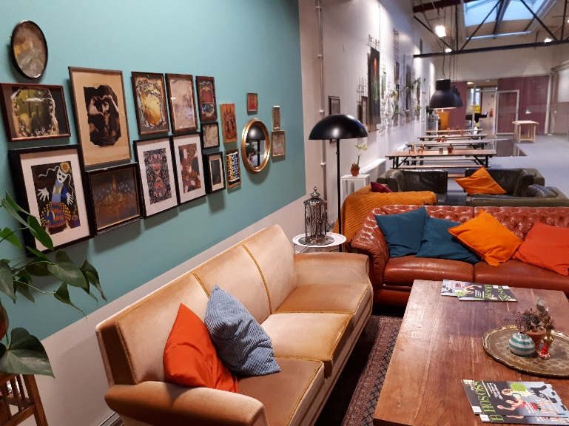 | Target audience:  The people in the munmicipality, tourists, inhabitans in the nearby municipalities  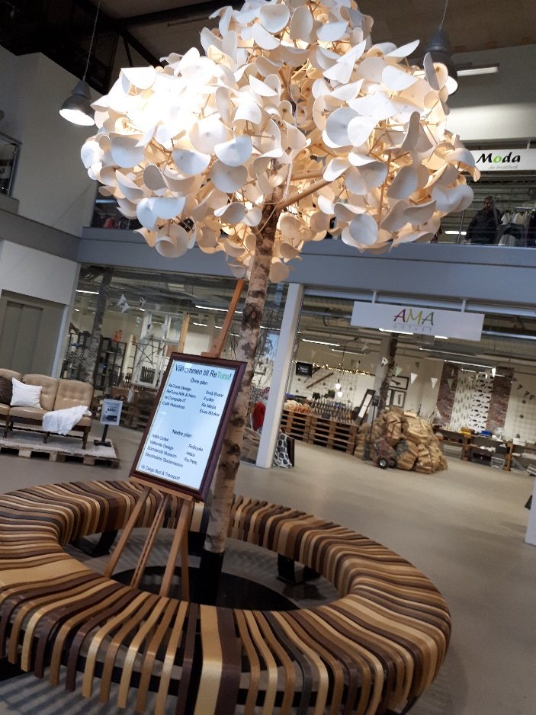
Perspective of use and dissemination:
A new way to look at reuse and recycling, it´s not in the backyard but in the front galleria.

“All material is taken from the website of Retuna”

