1. Name of the example/project
Invigning av Gavlehovhallen och 100 meter framtid (in Swedish)
“Opening of Gavlehov arena* and 100 metres of future”
*An indoor sport arena in Gävle in Sweden.
2. Background
In conjunction with the opening of the arena, the municipality of Gävle celebrated exceeding 100 000 inhabitants. An exhibition called 100 metres of future was formed, and Gästrike återvinnare participated both as an exhibitor and also as a coordinator for a small part of the exhibition.
3. Purpose
The main purpose of the exhibition was aimed at inspiring and challenging the visiting residents to think more about living a more sustainable lifestyle leading up to 2030. The different exhibitors showed various examples incorporating new techniques, simple choices and solutions everyone could use in their everyday life. Our part as Gästrike återvinnare was to demonstrate to the visiting inhabitants how to consume in a more sustainable way and how to sort their waste correctly.
Our purpose was also to inform the residents that food waste is being used to produce biogas at a new Plant just outside Gävle, so we stressed the importance of not mixing any plastic in the food waste.
4. Goals
Our goals were to inspire the residents to make sustainable choices and as also to get them to discuss their views on how to achieve these goals.
5. Planning
Messages, content and assignment was distributed during start up meetings.
During the planning process it was important that we emphasized our message to the residents of sustainable consumption and correct sorting of household waste. During the planning process we discussed what would be needed, who would do it and when it would be done.
6. Implementation – practical performance
A schedule was made what and when to do what. Meetings, e-mail and phone calls were used for checking progress and status on different tasks. On the day we were 5-6 persons setting up and taking down our exhibition, and we were 2-4 persons present during opening hours.

7. Practical Advice
- Be clear in your purpose and goals for the project.
- Be clear in what you expect from participating people, use deadlines, and repeatedly check status of assignments. Note decisions and distribute this to participants.
- Adapt goals and claims according to time and resources available.
- Use checklists with tasks (big and small), name responsible person and deadlines.
- Are you going to produce stuff, think sustainability! Reuse! Be creative and build from material and resources you already have. Always ask yourself: “Is this something you can reuse for a different occasion or task?”
- It’s a good idea to draw concept sketches on your plans and ideas, to make sure you all have the same picture of what is going on/needs to be created and so on. Pictures say more than words…
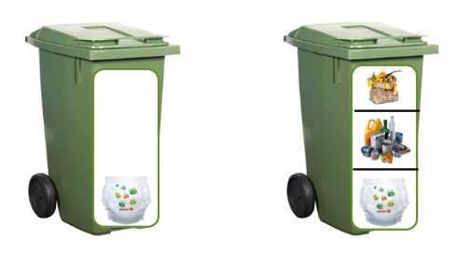
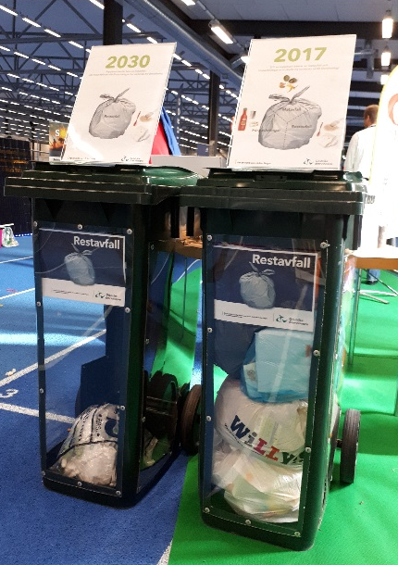

First sketch

Result in the end. These are going to be used even after this event.
8. Evaluation- results
It was short notice when we were involved, as a result we had to be efficient, creative and have clear planning.
When working on these kind of projects with different partners and organisations one has to be prepared for possible challenges due to illness or other unforeseen circumstances. From our initial planning due to the fact that we were included into the project on short notice we kept our planning basic and simple in order to avoid any drastic pitfalls. The outcome of our planning ensured that the project was a success.
We had a wide spectrum of visitors with varying knowledge in the area of sustainability and waste management, and it was a pleasurable experience engaging with them all.

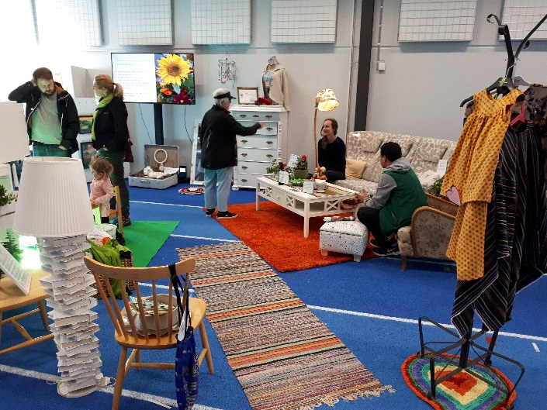
Second hand furniture and reused stuff; perhaps a sustainable home in 2030?

