Name of the Good Practice (give a title of 5 to 6 words max): Pedagogic example from Linköping | Contact:  Name:  Address:  Mail:
Domain concerned:  x Good Practice - General  ☐ Good Practice - Collection  Good Practice - Valorization | ☐ Good Practice - Sale  ☐ Good Practice - Sensitization

Implementation context (territory, starting point, ...)
To use a subject together with students and find aspects to work on with
Practice, method of intervention and objectives of the approach
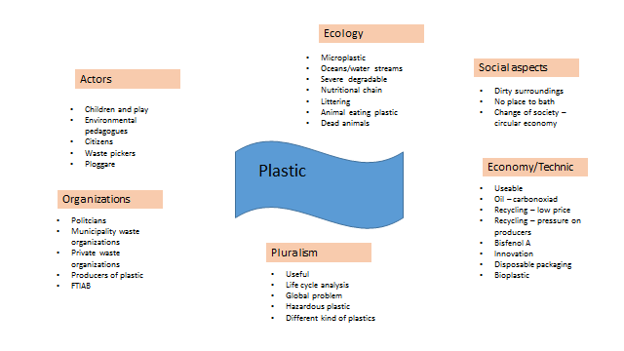

Results (impacts on the public, the territory, ...)  The discussion of impact of (plastic, Hazardous waste, etc). What can we do? | Target audience:  Students
Perspective of use and dissemination:

